**Literacy**

Animaphonics Phase 4- continue to use known letter sounds to read and write words. Read and write Rainbow words

Adapt or create our own stories, using our phonics to write captions and sentences.

Read, listen to and discuss stories.

Write labels and captions independently including using sound mats and using their phonics knowledge

Form lower-case and capital letters correctly.

Spell words by identifying the sounds and then writing the sound with letter/s.

Write labels and captions independently including using sound mats and using their phonics knowledge

Personal, Social and Emotional Development

Healthy Me

What do I need to do to be healthy and safe?

Zones of Regulation- Strategies to move zones.

Being a kind friend.

We will be talking ab new friends- Stranger danger

- Saying sorry

We will be talking about:

- Joining a new c We will be talking about:

- Joining a new class.

- Making new friends/

Introducing ourselves

- Panshanger Golden Rules

- Why we have rules

- What would happen if there

were no rules

- Building confidence and self-

esteem

- Sharing celebrations

- Taking care of each other

- Identifying ways in which

stories can

represent a moral

- Making choices

- Stranger danger

- Saying sorrylass.

- Making new friends/

Introducing ourselves

- Panshanger Golden Rules

- Why we have rules

- What would happen if there

were no rules

- Building confidence and self-

esteem

- Sharing celebrations

- Taking care of each other

- Identifying ways in which

stories can

represent a moral

- Making choices

- Stranger danger

- Saying sorry

Understanding the World

Explore the life cycle of ducks and share care and concern for living things.

Find out about different types of farms and where some of our food comes from.

Explore the changing seasons and Easter.

Expressive Arts and Design

Use our imagination to recreate familiar roles and stories. Use a range of media to create our own pictures and models. Follow and create their own dance movements.

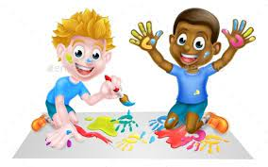

**Our topic is**

**New Beginnings**o 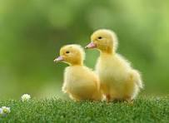

Communication and Language

Describe events in some detail, including sequencing connectives such as then, next,

Ask and answer questions.

Recite a well- known poem or song.

**Physical Development**

Further develop and refine a range of ball skills including: throwing, catching, kicking, passing, batting, and aiming.

Continue to develop our fine motor skills and form letters accurately.

**Maths**

Exploring the composition of numbers to ten.

Measuring using non-standard units.

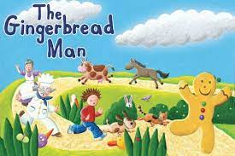

**Please continue to encourage your child to develop their independence, especially when getting dressed/ undressed.**

**During the summer term we will be going swimming and the children will need to be largely independent in managing their needs. Of course we will help them if they really need it, but the next couple of months is a great opportunity to give it a go!**

**Please don’t hesitate to contact me on** [**karen.claridge@panshanger.herts.sch.uk**](mailto:karen.claridge@panshanger.herts.sch.uk)

**Message me on Tapestry or catch me at the door at home time.**

Please read with your child at home as much as possible. School expectations are that you listen to your child read and write in your reading record at least 3 times a week.

Please support your child to confidently know their letter and Rainbow word flashcards by sight.

Our PE days will continue to be Mondays and Wednesdays. Please ensure all earrings are out in these days.

On Wednesdays the children will be walking over to Ridgeway for the next few weeks, so please make sure they have clean trainers.

**Please ensure children bring in their (named) water bottle every day. They are welcome to bring in a healthy snack which they can have during the morning or afternoon if they get hungry. As part of the Government scheme, children are provided with a piece of fruit/ vegetable daily, but we do not know what this will be in advance.**

**Information and home learning**

**The children will have the opportunity to go outside as much as possible, so please ensure they always have a coat in school.**

**PLEASE, PLEASE, PLEASE make sure all items are named.**