**Science**

* **This half term we are learning about plants.**
* **Making observations of different types of plants and identifying similarities and differences.**
* **Comparing seeds and bulbs and observing plants as they grow.**
* **Finding out about germination and where seeds come from.**

**Computing**

* ***What is Information Technology?***
* **Learning about what it is and when it is used at home, at school and in the wider world.**

**PSHE**

* **Talking about our hopes and fears for Y2.**
* **Working cooperatively with others.**
* **Learning about rights and responsibilities in our classroom.**

- Saying sorry

We will be talking about:

- Joining a new c We will be talking about:

- Joining a new class.

- Making new friends/

Introducing ourselves

- Panshanger Golden Rules

- Why we have rules

- What would happen if there

were no rules

- Building confidence and self-

esteem

- Sharing celebrations

- Taking care of each other

- Identifying ways in which

stories can

represent a moral

- Making choices

- Stranger danger

- Saying sorrylass.

- Making new friends/

Introducing ourselves

- Panshanger Golden Rules

- Why we have rules

- What would happen if there

were no rules

- Building confidence and self-

esteem

- Sharing celebrations

- Taking care of each other

- Identifying ways in which

stories can

represent a moral

- Making choices

- Stranger danger

- Saying sorry

**Welcome to Year 2.**

**We have lots of exciting topics to inspire our learning and to help us develop our skills in reading, writing, thinking, talking and problem solving.**

 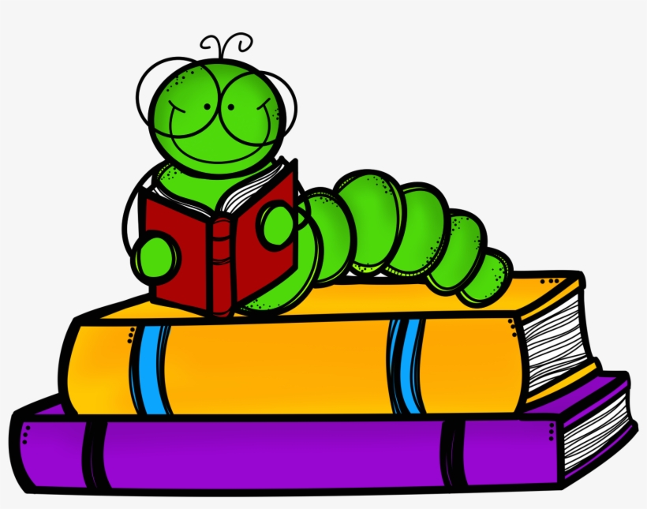 

**PE**

**• Games lessons will concentrate on key skills of throwing and catching balls and aiming**

**• Gymnastics lessons will focus on using small apparatus and developing balances and linking moves.**

**Music**

* **Playing high and low sounds**
* **Identifying tuned and untuned instruments**

**Art**

* **Exploring making lines using different media including printmaking.**
* **Creating texture and pattern.**
* **Exploring the art of Yayoi Kusama.**

**Geography**

**• Learning about the continents and oceans.**

* **Using an atlas to locate places.**
* **Learning geographical facts about different places.**

**RE**

* **Learning about signs and symbols in the world around us and across different religions.**

**English**

* **Sharing exciting stories by different authors to inspire our own writing including different versions of traditional tales.**
* **Writing sentences using accurate punctuation.**
* **Reading individually and in small groups to develop fluency.**
* **Revising phonics from Y1 & applying to spelling.**
* **Learning new spelling patterns and spelling the year 1 and year 2 key words.**
* **Practising correct letter formation and positioning on the line.**

**Maths**

**• Daily lessons including one main session and one short fluency session.**

* **Number and place value will be the focus to begin with as it is the core to all maths learning.**
* **Continue to learn about addition and subtraction including mental calculation strategies and recogning patterns.**

**• In all lessons the children will be learning to use mathematical language to explain their decisions and results.**

**Homework Activities**

Reading daily is essential for building confidence and fluency. Please fill in the reading record **at least 3 times a week**. This can be the school reading book or a book from home. Reading records will be checked on Friday; if they have not been filled in the children will read with a reading buddy at playtime.

We are following the Animphonics programme for spelling. Every **Friday** I will send home a list of words to practise that week’s spelling pattern. The children will be tested on some of these words the following **Thursday**.

We will be using Teach Your Monster to Read games in class and the children will bring home their login details so they can use it at home. It is available on the website or via the app (available on apple and android).

Activities to practise maths at home could include using money, telling the time and practising quick recall of number facts. White Rose Maths have produced an excellent app to support quick recall of facts. Further details available here: <https://whiterosemaths.com/1-minute-maths>

PE Kit

PE will usually be on Thursdays and Fridays but children should have their PE bags in school everyday in case of timetable changes. The children should have;

a colour tshirt for their team, navy shorts, navy jogging bottoms, navy jumber and trainers. It is useful to have spare underwear and socks in the PE bag in case of accidents.

Children with earrings need bring in their own micropore tape to cover their earrings or they should not be worn.

**Welcome to Year 2!**

This year I will be joined in the classroom by Mrs Graves who will be supporting the children throughout the week and Mrs Jeffrey who will be teaching RE and PE on Thursday afternoons. Mr Mitchell continues to teach music on Tuesdays.

**Reminders**

The children should bring their book bag to school everyday with their reading book, reading record and spelling book.

We would prefer this to be a book bag or similar as we do not have space in our cloakroom for large backpacks. We would also appreciate it if PE bags could be the draw-string type as they take up less space. The children only have one peg on which to hang both bags and their coat.

The children should bring a water bottle every day containing water – no juice please. They may also bring a healthy snack for break time if they wish. It is helpful if this is named.

We will go outside for lessons and playtimes whatever the weather so the children should have a waterproof coat.

**Tapestry**

I will be using Tapestry to send out messages and information about what we have been doing in class and set any additional home learning activities. Everyone has been added to the Year 2 2023-2024 class journal which is where I will be posting – usually on Friday afternoon so please do remember to check. The children’s individual journals are still active so you can still post any achievements or home learning. If you have any problems accessing Tapestry please get in touch.

Please don’t hesitate to contact me if you have any queries or concerns either by ringing the school office or by email:

[emma.waring@panshanger.herts.sch.uk](mailto:emma.waring@panshanger.herts.sch.uk)

Mrs Waring