**Personal, Social and Emotional Development**

We will be exploring what friendship means including how to be a good friend, what it means to be lonely and how we can cope with fallings out.

We will also continue to explore how to keep healthy and safe.



We will be talking ab new friends- Stranger danger

- Saying sorry

We will be talking about:

- Joining a new c We will be talking about:

- Joining a new class.

- Making new friends/

Introducing ourselves

- Panshanger Golden Rules

- Why we have rules

- What would happen if there

were no rules

- Building confidence and self-

esteem

- Sharing celebrations

- Taking care of each other

- Identifying ways in which

stories can

represent a moral

- Making choices

- Stranger danger

- Saying sorrylass.

- Making new friends/

Introducing ourselves

- Panshanger Golden Rules

- Why we have rules

- What would happen if there

were no rules

- Building confidence and self-

esteem

- Sharing celebrations

- Taking care of each other

- Identifying ways in which

stories can

represent a moral

- Making choices

- Stranger danger

- Saying sorry

**Understanding the World**

**We will be looking at plants and how they grow.**

**We will also be looking at mini-beasts including the lifecycle of a Butterfly.**

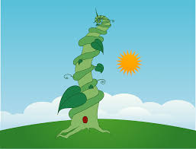

**Expressive Arts and Design**

**We will be exploring colour mixing, joining materials and using instruments to express feelings and ideas.**



**Our topics are;**

**Lifecycles – Plants and Butterflies**

**Healthy Me Healthy Friendships**

**Key Date – 7th May visit to Fox Holes Farm (all day)**

**Communication and Language**

We will be focussing on listening for longer periods of time. We will be particularly focussing on sustaining attention for longer in stories and being able to reason when we answer question such as using the word because. We will also keep practicing turn taking and waiting your turn when speaking.

**Physical Development**

We will be practising forming the letters of our name.



**Maths**

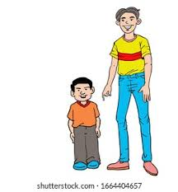 We will be making comparisons in height and exploring positional language. We will also be continuing our number work exploring the composition of numbers to five and reciting and ordering numbers to 10.

**English** a

Polysyllabic words

Core Texts – Jack and the Beanstalk and The Hungry Caterpillar. We will be using these to practice retelling a well- known story.

In Phonics we will look at the structure of words, breaking them down into onset and rime and syllables.

**Go on a subitising walk, inside or outside!**

**(watch this video** [**https://www.youtube.com/watch?v=bX3i6g7in0M**](https://www.youtube.com/watch?v=bX3i6g7in0M) **to help you understand) You could look for 1, 2 or 3 objects.**

**Go on a phoneme hunt can you spot the letters we have been learning?**

**Week 1 – s a t p week 5 – h b f l**

**Week 2 – i n m d week 6 – j v w x**

**Week 3 –g o c k week 7 – y z qu ch**

**Week 4 – ck e u r**