**English**

* Phonics - Begin the Animaphonics scheme with phase 2 phonemes
* Segmenting words into separate sounds and blending to read words
* Reading CVC (consonant/vowel/consonant) words
* Listening to and retelling stories.
* 1:1 reading of phonemes, words and simple texts
* Shared writing for a purpose e.g. writing invitations, lists, cards,
* Listening to and retelling well known stories

**Personal, Social and Emotional Development**

* **All about me – being me in my world**
* **Settling into life in Reception**
* **Making new friends and taking care of each other**
* **Panshanger School expectations**



We will be talking ab new friends- Stranger danger

- Saying sorry

We will be talking about:

- Joining a new c We will be talking about:

- Joining a new class.

- Making new friends/

Introducing ourselves

- Panshanger Golden Rules

- Why we have rules

- What would happen if there

were no rules

- Building confidence and self-

esteem

- Sharing celebrations

- Taking care of each other

- Identifying ways in which

stories can

represent a moral

- Making choices

- Stranger danger

- Saying sorrylass.

- Making new friends/

Introducing ourselves

- Panshanger Golden Rules

- Why we have rules

- What would happen if there

were no rules

- Building confidence and self-

esteem

- Sharing celebrations

- Taking care of each other

- Identifying ways in which

stories can

represent a moral

- Making choices

- Stranger danger

- Saying sorry

**Understanding the World**

* **Exploring our senses**
* **Harvest**
* **Exploring our local community**
* **Changing seasons**



**Expressive Arts and Design**

* **Self-Portraits**
* **Representations of our family painting, collage, loose parts.**
* **Responding to pitch and rhythm**



**Our theme is**

**Tell me a story**

**Communication and Language**

* **Talking about me and my family**
* **Listening to one another**
* **Using story language to retell stories**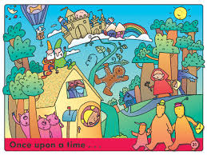

**Physical Development**

* **Learning to form letters within your name**
* **Scissors, gluing and sticking skills**
* **Activities to develop finger strength**
* **Moving on different equipment**
* **Climbing and balancing**
* **Moving safely on feet and balance bikes**

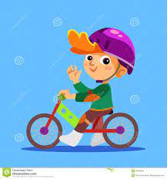

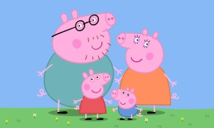

**Maths**

* Subitising: to recognise quantities without having to count them.
* Sorting, matching and classifying: sorting objects into sets, matching pairs of objects, sorting themselves by the colour of their hair/ clothes they are wearing etc
* Comparing amounts, size, capacity and mass.
* Recognising and continuing a pattern

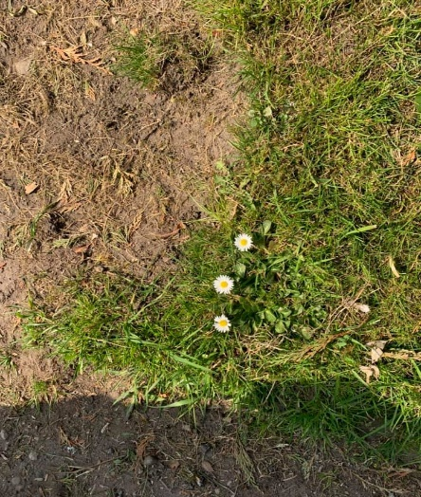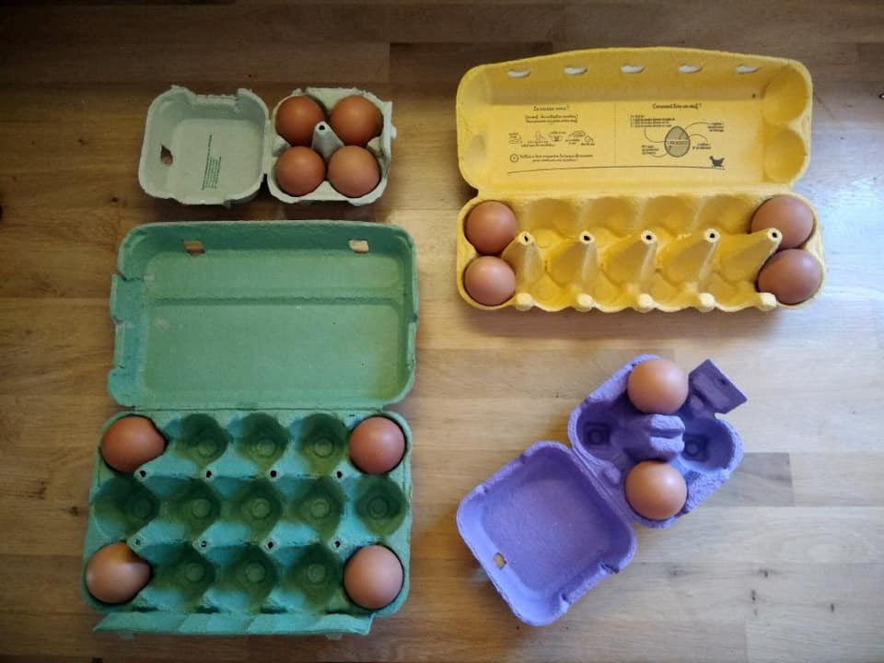T

**If you have any questions or concerns please do not hesitate to get in touch. You can always catch me at the door after school, send me an email** [**karen.claridge@panshanger.herts.sch.uk**](mailto:karen.claridge@panshanger.herts.sch.uk) **or contact me on Tapestry. If it is something urgent please phone the office who can then get a message to me.**

**Go on a phoneme hunt can you spot the letters we have been learning?**

**Week 1 – s a t p week 5 – h b f l**

**Week 2 – i n m d week 6 – j v w x**

**Week 3 –g o c k week 7 – y z qu ch**

**Week 4 – ck e u r**

**Go on a subitising walk, inside or outside!**

**(watch this video** [**https://www.youtube.com/watch?v=bX3i6g7in0M**](https://www.youtube.com/watch?v=bX3i6g7in0M) **to help you understand) You could look for 1, 2 or 3 objects.**

**We will go outside as much as possible in all weathers, so please make sure that the children have appropriate clothing for the weather.**

**Please make sure your child has a named water bottle. We will refill it in school when needed.**

- Making choices

- Stranger danger

- Saying sorry

**Reception will have PE on Mondays and Wednesdays. Please make sure all earrings are taken out on these days.**

**Information and ideas to support learning at home**.

**Tell a story to a family member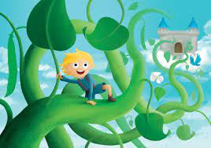nd.**

**Please read with your child at least 3 times a week and record this in their reading record**