**Personal, Social and Emotional Development**

* **Celebrating differences**
* **Identifying own emotions.**
* **Sharing with others**

We will be talking ab new friends- Stranger danger

- Saying sorry

We will be talking about:

- Joining a new c We will be talking about:

- Joining a new class.

- Making new friends/

Introducing ourselves

- Panshanger Golden Rules

- Why we have rules

- What would happen if there

were no rules

- Building confidence and self-

esteem

- Sharing celebrations

- Taking care of each other

- Identifying ways in which

stories can

represent a moral

- Making choices

- Stranger danger

- Saying sorrylass.

- Making new friends/

Introducing ourselves

- Panshanger Golden Rules

- Why we have rules

- What would happen if there

were no rules

- Building confidence and self-

esteem

- Sharing celebrations

- Taking care of each other

- Identifying ways in which

stories can

represent a moral

- Making choices

- Stranger danger

- Saying sorry

**Communication and Language**

* **Responds to questions**
* **Follows 2 part instructions**
* **Recalls past events and listens to others**

**Physical Development**

* Dance- Developing timing and following routines and pathways.
* Developing correct letter formation.
* Continue to develop general body strength.

**Our theme is**

**Let’s Celebrate**

We will find out about celebrations such as Diwali and Christmas. We will explore light, dark and **space.**

**Understanding the World**

* **Exploring some historic events.**
* **Explore different festivals and know that people celebrate different things.**
* **Use positional language.**

**Expressive Arts and Design**

* **Learning new songs**
* **Performing to an audience.**
* **Explore colour mixing**
* **Van Gogh- The Starry Night**

**English**

* Phonics – Continue with Animaphonics scheme with phase 3 phonemes
* Segmenting words into separate sounds and blending to read words
* Reading CVC (consonant/vowel/consonant) words
* Listening to and retelling stories.
* 1:1 reading of phonemes, words and simple texts
* Shared writing for a purpose e.g. writing invitations, lists, cards,
* Listening to and retelling well known stories

**Maths**

* Subitising: to recognise quantities without having to count them.
* Composition of number to 5
* Begin to represent number and use mathematical signs.
* To know some number bonds.

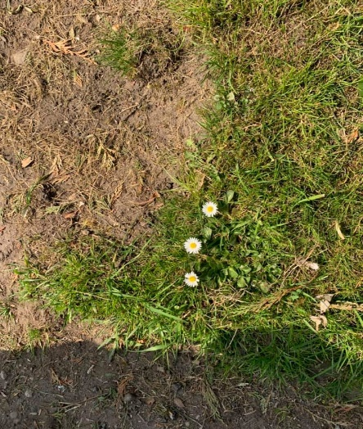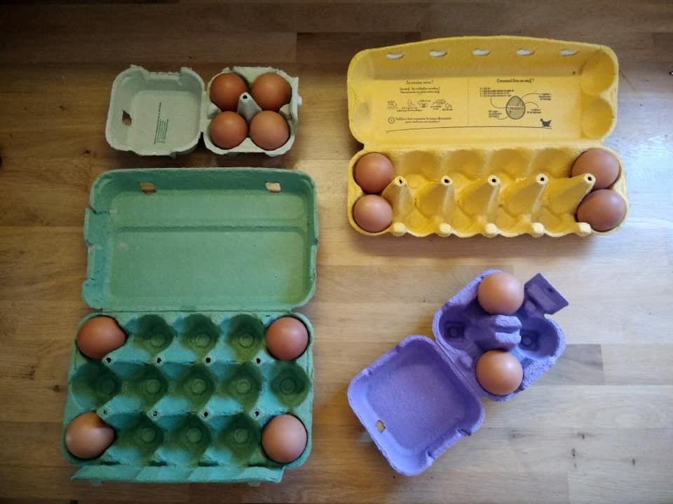T

**Please, Please, Please**

make sure **all** your children’s belongings are clearly labelled.

Please read with your child at least 3 times a week and record this in their reading record

**If you have any questions or concerns please do not hesitate to get in touch. You can always catch me at the door after school, send me an email** [**karen.claridge@panshanger.herts.sch.uk**](mailto:karen.claridge@panshanger.herts.sch.uk) **or contact me on Tapestry. If it is something urgent please phone the office who can then get a message to me.**

**Go on a sound hunt. Can you spot the sounds we have been learning?**

**Week 8 –y, z, qu, ch week 12 – ear, ow, ur, oi**

**Week 9 – sh, th, ng week 13 – air, ure, er, ue**

**Week 10 – ee, ar, oa, or**

**Week 11 – 00, ai, igh**

**The children will be taking part in a Christmas Performance. Your child may shortly bring home some lines to learn. Please support them by helping them to learn their lines. All costumes will be provided by the school. The children will also be learning some songs and a dance for the performance.**

We will go outside as much as possible in all weathers, so please make sure that the children have appropriate clothing for the weather.

Please make sure your child has a named water bottle. We will refill it in school when needed.

- Making choices

- Stranger danger

- Saying sorry

Reception will have PE on Mondays and Wednesdays. Please make sure all earrings are taken out on these days.

**Information and ideas to support learning at home**.