**Personal, Social and Emotional Development**

Exploring different relationships and how to be a good friend.

Understanding different emotions and explore strategies for when things go wrong.

- Saying sorry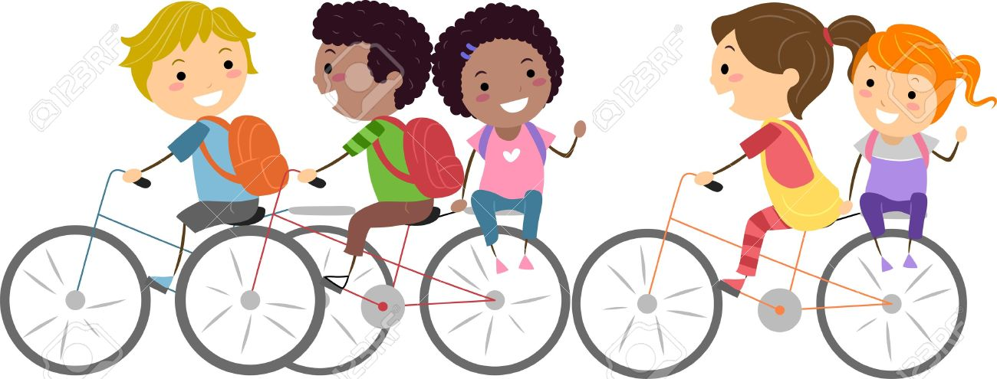

We will be talking about:

- Joining a new c We will be talking about:

- Joining a new class.

- Making new friends/

Introducing ourselves

- Panshanger Golden Rules

- Why we have rules

- What would happen if there

were no rules

- Building confidence and self-

esteem

- Sharing celebrations

- Taking care of each other

- Identifying ways in which

stories can

represent a moral

- Making choices

- Stranger danger

- Saying sorrylass.

- Making new friends/

Introducing ourselves

- Panshanger Golden Rules

- Why we have rules

- What would happen if there

were no rules

- Building confidence and self-

esteem

- Sharing celebrations

- Taking care of each other

- Identifying ways in which

stories can

represent a moral

- Making choices

- Stranger danger

- Saying sorry

**Communication and Language**

Speaking with confidence to familiar people.

Remembering to always use our manners

Use talk to negotiate situations and resolve conflict.

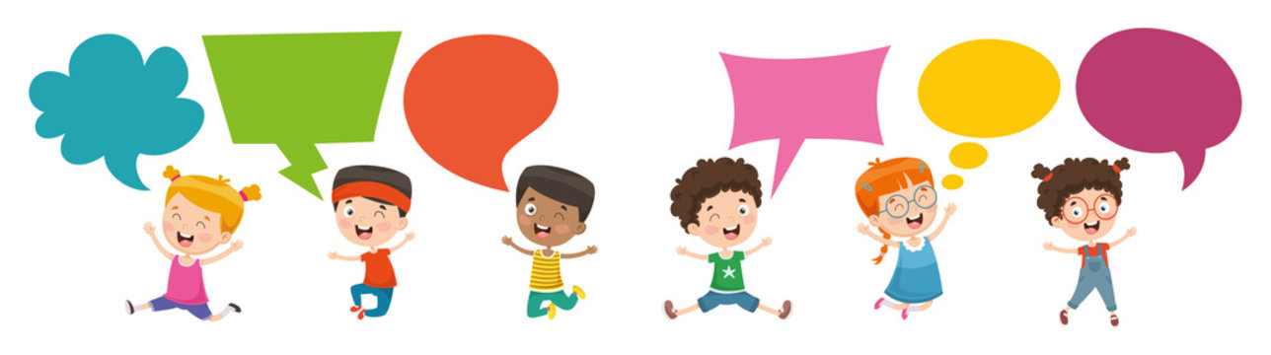

**Physical Development**

Form most lower case letters correctly

Play simple team games developing an understanding of how to be a good sport and team mate.

Use tools safely with increasing confidence in the classroom and when exploring outside.

. 

**Expressive Arts and Design**

Use a range of media to express their ideas and feelings.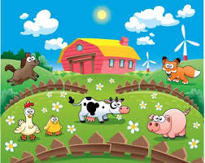

**Our topic is**

**The Great Outdoors**



**Understanding the World**

Explore the life cycle of a butterfly.

Exploring outdoor places, both locally and in different countries.

To plant a seed and know what it needs to survive.

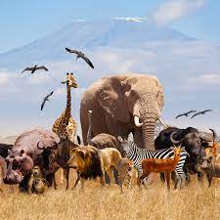

**Literacy**

Continue with Anima Phonics, progressing onto Phase 5a.

To talk about stories that we have read.

To write simple captions and sentences, using their phonic knowledge.

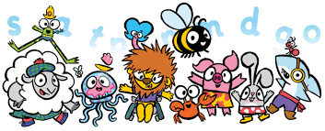

**Maths**

Counting to 10 and beyond.

Compose and decompose number

Calculate how many and group and share objects.



Home Learning Challenges

Can you get dressed and undressed unaided? (ready for swimming after half term)

Can you count (up to 20) objects and share them equally between a small group of people?

Can you go for a walk in the woods and talk about what you see?

Can you play a game being a “good sport” understanding that you may not always win?

**Our topic is**

**The Great Outdoors**

**Information and Home Learning Activities**

Please make sure your child has a named water bottle in school. When (hopefully) the weather warms up please make sure your child has a sun hat in school and has sun cream applied before school.

The children have been working really hard to develop their writing skills. Here are some ideas to support this at home-

-Continue to develop their fine motor skills by using play dough, tweezers, threading or twisting lids.

-Develop their gross motor skills by climbing, swinging, riding a bike, throwing, catching or building an obstacle course.

-Write a shopping list

-Write instructions to show how to do something.

-Write labels, cards or their own stories.

Write words in flour, shaving foam, rice.

-Use chalk or paint with water outside to write letters or words.

Encourage your child to hold their pencil using a tripod pincer grip and encourage them to take their time to form letters correctly. Support your child to use known letter sounds to sound out words or help them recall their Rainbow Words.

.

Reception will continue to have PE on Mondays and Wednesdays.

Please make sure earrings are removed on these days.

On Mondays we will be going outside, so please make sure they have trainers.

were no rules

- Building confidence and self-

esteem

- Sharing celebrations

- Taking care of each other

- Identifying ways in which

stories can

represent a moral

- Making choices

- Stranger danger

- Saying sorrylass.

- Making new friends/

Introducing ourselves

- Panshanger Golden Rules

- Why we have rules

- What would happen if there

were no rules

- Building confidence and self-

esteem

- Sharing celebrations

- Taking care of each other

- Identifying ways in which

stories can

represent a moral

- Making choices

- Stranger danger

- Saying sorry

**Please remember to continue to share the children’s news and achievements on Tapestry**.

Please continue to read with your child at home and record this in their reading record.

Your child should also have flash cards of our Rainbow Words. Your child would really benefit from reading and writing these words at home.

Reception will be going to Foxholes Farm in Hertford, for the Foundation Stage trip on **Tuesday 7th May.** Further details will be sent out soon.