Science

In Science children will learn about ‘Everyday Materials’. They will have the opportunity to explore the properties of different materials and carry out simple investigations . We will be focussing on the season Autumn and the changes we see.

**Computing -** Technology around Us. We will be looking at how technology helps us, the parts of a computer, developing our mouse & keyboard skills and how to use technology safely.

**PSHE -** Resilience and mental wellbeing through a range of discussions and activities

**Welcome back!**

**Our main topics this term are Toys and Materials**.

We hope you all had a fantastic summer break and are ready for an exciting year in Year 1!

The Year 1 team consists of Miss Turner, Mrs Deacon and Mrs Jeffrey.

**English -** English will be based on stories that follow patterns, rhymes and familiar events, factual writing included writing captions, labels and simple information texts. There will be opportunities to read weekly with an adult and in a small group for guided reading, both will provide opportunities to practise the skills of decoding and learning the key words.

**Phonics** lessons will focus on reinforcing letter names and blending sounds for reading. Phonics will be linked to regular handwriting opportunities to practise letter formation. The children will be continuing the Animaphonic scheme. There are some excellent games and activities on [www.phonicsplay.co.uk](http://www.phonicsplay.co.uk).

**PE**

PE lesson will be on a Wednesday (pm) and Thursday (am) Please ensure children have their kits in school on these days. This term the chdlren will be exploring different movement skills and gymnastics. 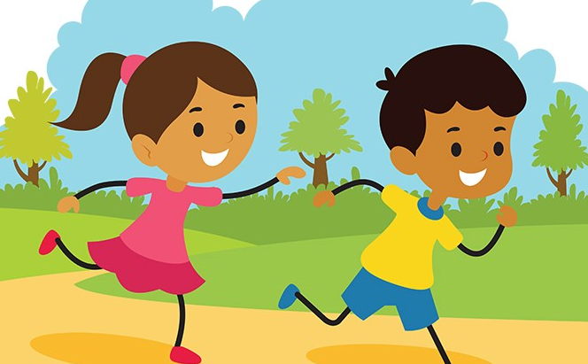

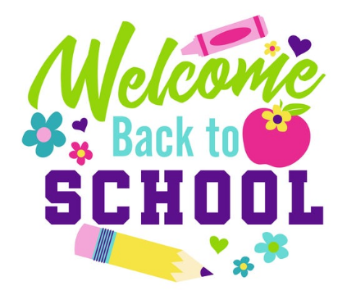

**Humanities (History, Geography & RE)**

Our Humanities topic is ‘Toys’ - as a class we will be looking at toys through time, comparing and discussing toys that the children play with and toys that our grandparents would’ve had.

In RE the children will be focussing on creation and celebration for different faiths. We will be exploring creation stories and how different festivals are celebrated.

**Maths**

Daily lessons will include one main session and 4 short fluency sessions.

The main maths topics will be:

* **Number: Place value (within 10)** -this will include sorting, counting, reading, writing and ordering numbers to 10, forwards and backwards.
* **Number: Addition (within 10)** -this will include finding and comparing number bonds for numbers within 10 and addition by adding together, and by adding more.



**REMINDERS:**

* Please provide you child with **a named water bottle** for use in the classroom. It should not contain juice or squash as a Healthy School we want to promote water as the best drink throughout the day. Please ensure that packed lunches do not contain any items with nuts. If you send a snack for your child, please choose a healthy one (not chocolate) – fruit or vegetable snacks are provided in school each day.
* **PE will be on a Monday afternoon and Thursday morning**. Your child will need navy shorts and a t-shirt in their house colour, but as most lessons will be taking place outside, please also ensure they have suitable warmer clothing i.e. plain navy jogging trousers and sweatshirt. They will also need suitable trainers for outdoor PE.
* If children have shoes with laces they need to be able to tie them independently.
* Please provide hairbands to tie back long hair. Should your child have pierced ears, tape must be provided to cover the earrings during PE times in accordance with Health and Safety rules. A spare pair of socks in their PE bags is also very useful. Please ensure all items of clothing and equipment are clearly named.
* Ensure that your child has correct school uniform including dark plimsolls and plain socks. Refer to the School Website to remind you about rules regarding school uniform. Nail varnish and tattoos should not be worn at school and reminders will be given to remove them if the need arises.

Please don’t hesitate to email / ring / contact if you have any queries or concerns:

[Naomi.turner@panshanger.herts.sch.uk](mailto:Naomi.turner@panshanger.herts.sch.uk)

We will also continue to use Tapestry as a means of contact.

Music:

Music lessons will continue with Mr Mitchell, focussing on the development of the differences between rhythm and pulse through improvised movement exercises, singing games and playing instruments.

Art:

In Art sessions the children will have the opportunity to use a range of materials. They will use a range of work from artists, craft makers and designers.

**Homework activities:**

Frequent **reading** practice will help your child to become a fluent reader. This will give them practise at decoding new words using their phonic knowledge and opportunities to learn the key words by sight. Endeavour to spend 10 - 15 minutes each day reading with / to your child and practising key words.

The children need to have **reading recorded 3 times a week**, practice will support your child to become a fluent reader. This will help them to decode new words using their phonic knowledge and to learn key words by sight.



Useful Websites to support learning

1. [www.phonicsplay.co.uk](http://www.phonicsplay.co.uk/)
2. <https://www.oxfordowl.co.uk/for-home>
3. [www.ictgames.com](http://www.ictgames.com/)
4. <https://www.topmarks.co.uk/> Search for subject and year group.
5. <http://www.primaryhomeworkhelp.co.uk/> Lots of different topics if children want to research one of our topics.
6. <https://www.dkfindout.com/uk/> Again this covers lots of topics and has a parent’s section.
7. [www.bbc.co.uk/schools/ks1bitesize](http://www.bbc.co.uk/schools/ks1bitesize)
8. [www.woodlands-junior.kent.sch.uk/Homework](http://www.woodlands-junior.kent.sch.uk/Homework)