**REMINDERS:**

* Please provide you child with **a named water bottle** for use in the classroom. It should not contain juice or squash as a Healthy School we want to promote water as the best drink throughout the day. Please ensure that packed lunches do not contain any items with nuts. If you send a snack for your child, please choose a healthy one (not chocolate) – fruit or vegetable snacks are provided in school each day.
* **PE will be on a Wednesday afternoon and Thursday morning**. Your child will need navy shorts and a t-shirt in their house colour, but as most lessons will be taking place outside, please also ensure they have suitable warmer clothing i.e. plain navy jogging trousers and sweatshirt. They will also need suitable trainers for outdoor PE.
* If children have shoes with laces they need to be able to tie them independently.
* Please provide hairbands to tie back long hair. Should your child have pierced ears, tape must be provided to cover the earrings during PE times in accordance with Health and Safety rules. A spare pair of socks in their PE bags is also very useful. Please ensure all items of clothing and equipment are clearly named.
* Ensure that your child has correct school uniform including dark plimsolls and plain socks. Refer to the School Website to remind you about rules regarding school uniform. Nail varnish and tattoos should not be worn at school and reminders will be given to remove them if the need arises.

Please don’t hesitate to email / contact if you have any queries or concerns:

[Naomi.turner@panshanger.herts.sch.uk](mailto:Naomi.turner@panshanger.herts.sch.uk)

We will also continue to use Tapestry as a means of contact.

Music: Music lessons will continue with Mr Mitchell focussing on the development of the differences between rhythm and pulse through improvised movement exercises, singing games, instrumental playing and identifying.

Art: In Art sessions the children will have the opportunity to use a range of materials - drawing, painting and developing design techniques in using colour, pattern, texture, line, shape, form and space. They will experience a range of artists, craft makers and designers,



Useful Websites to support learning

1. [www.phonicsplay.co.uk](http://www.phonicsplay.co.uk/)
2. <https://www.oxfordowl.co.uk/for-home>
3. [www.ictgames.com](http://www.ictgames.com/)
4. <https://www.topmarks.co.uk/> Search for subject and year group.
5. <http://www.primaryhomeworkhelp.co.uk/> Lots of different topics if children want to research one of our topics.
6. <https://www.dkfindout.com/uk/> Again this covers lots of topics and has a parent’s section.
7. [www.bbc.co.uk/schools/ks1bitesize](http://www.bbc.co.uk/schools/ks1bitesize)
8. [www.woodlands-junior.kent.sch.uk/Homework](http://www.woodlands-junior.kent.sch.uk/Homework)

**Homework activities:**

Frequent **reading** practice will help your child to become a fluent reader. This will give them practise at decoding new words using their phonic knowledge and opportunities to learn the key words by sight. Endeavour to spend 10 - 15 minutes each day reading with / to your child and practising key words.

The children need to have **reading recorded 3 times a week**, practice will support your child to become a fluent reader. This will help them to decode new words using their phonic knowledge and to learn key words by sight. Reading the same book 3 times helps with decoding, fluency and comprehension.





**Humanities (History, Geography & RE)**

Our Humanities topic is ‘Our local area’. The children will be exploring the local environment and map work.



In RE the children will learn about light and festivals, including the celebrations of Hanukkah and Christmas.

Science

In Science the children will learn about the seasons and how these change. They will make careful observations and links to real life events. We will also be continuing our work on materials.

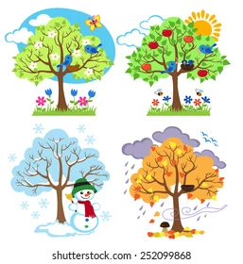

**Maths**

The main maths topics will be:

* **Number:** Subtraction (within 10) -This will include using the subtraction symbol; subtracting by crossing out, counting backwards and finding the difference; and comparing addition and subtraction statements.
* **Shape:** This will include recognising, naming and sorting 2D and 3D shapes. We will also look at recognising and creating patterns.

We hope you all had a fantastic half term break and are ready for an exciting term on the build up to Christmas! year in Year 1!

**PE**

PE lesson will be on a Monday (PM) and Thursday (AM) Please ensure children have their kits in school on these days. We will be doing dance and gymnastics where the children will begin to move their bodies with control and complete basic balances. 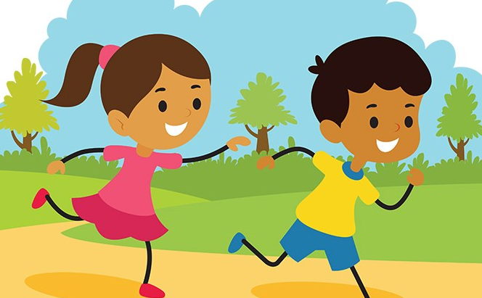

**English -** English will be based on a variety of genre including instructional writing, stories and information texts. Writing will focus on sentence structures and punctuation. There will be opportunities to read weekly with an adult and in a small group for guided reading which will provide opportunities to practise the skills of decoding and learning the key words

**Phonics** lessons will focus on reinforcing letter names and blending sounds for reading. We will be continuing the phase 5B unit of our Anima phonics unit. Phonics will be linked to regular handwriting opportunities to practise letter formation. There are some excellent games and activities on [www.phonicsplay.co.uk](http://www.phonicsplay.co.uk).

Welcome back!

Our topics this term are ‘Our local area’ and ‘Seasonal change’.

**Computing -** We will beginning our digital art unit, where the children are able to explore a range of digital art techniques.

**PSHE -** Resilience and mental wellbeing taught through a range of discussions and activities.