**Science**

In Science the children will learn about ‘Seasonal Changes’ which will focus on the changes between Winter to Spring and Spring to Summer. We will be recording the weather each day to find patterns and will learn about different aspects of these two seasons.

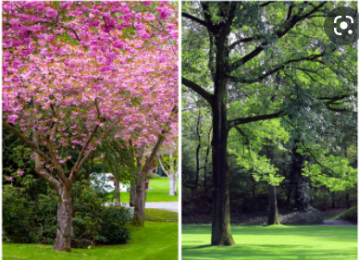

**Computing –**This term we will be looking at grouping data and how we can use technology to help us do this.

**PSHE -** Our theme this term is ‘Healthy Me’ which will be taught through a range of discussions and activities, which will help the children learn to make their own healthy choices.

- Saying sorry

We will be talking about:

- Joining a new c We will be talking about:

- Joining a new class.

- Making new friends/

Introducing ourselves

- Panshanger Golden Rules

- Why we have rules

- What would happen if there

were no rules

- Building confidence and self-

esteem

- Sharing celebrations

- Taking care of each other

- Identifying ways in which

stories can

represent a moral

- Making choices

- Stranger danger

- Saying sorry lass.

- Making new friends/

Introducing ourselves

- Panshanger Golden Rules

- Why we have rules

- What would happen if there

were no rules

- Building confidence and self-

esteem

- Sharing celebrations

- Taking care of each other

- Identifying ways in which

stories can

represent a moral

- Making choices

- Stranger danger

- Saying sorry

**Welcome back!**

**We hope you have had a restful half term!**

**Our main topics this term are ‘The United Kingdom’ and ‘Seasonal changes.’**

**’**

**English -** We will be focusing on story writing including writing sentences independently using the correct punctuation and extending sentences. We are also going to focus on rhyming in poetry and ordering events in non-fictional writing. There will be lots of opportunities for reading in order to practise decoding and recognising a wider range of words by sight.



Year 1 **phonics** screening takes place in the summer term (W/B 10th of June).

There are some excellent games and activities on [www.phonicsplay.co.uk](http://www.phonicsplay.co.uk). As always reading with the children and practicing the graphemes will help aid the children in their learning.

Please done hesitate to get in contact for any support.

**PE**

In PE our focus is circuits and bat and ball skills. We will be developing these skills through range of different actives and games. 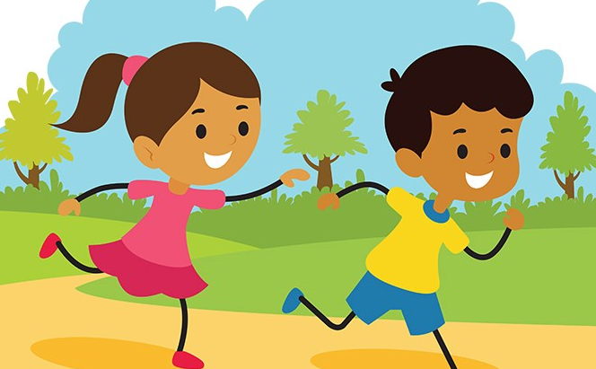

**Maths -** Daily lessons will include one main session and 3 short fluency sessions. The main maths topics will be:

* Measuring- This will focus on length, height, volume and weight. We will be making different measurements and will compare them through the combination of non-standard unit measurements and unit measurements such as cm.
* Place value (within 50) - This will include counting forwards, backwards and writing the numbers to 50 (in numerals and words); tens and ones; one more and one less; comparing and ordering groups of objects and numbers to 50.

h

**Humanities (History, Geography & RE)**

Our Humanities topic is ‘Our Country’. The children will be exploring the difference between the countryside and towns. They will also be looking at the United Kingdom and its 4 countries and comparing cities in different continents.

**

In RE, the children will look at the theme of ‘What is important?’ This will include a focus on Christianity, including stories told by Jesus and the significance of Easter.

**REMINDERS:**

Please provide you child with **a named water bottle** for use in the classroom. It should not contain juice or squash as a Healthy School we want to promote water as the best drink throughout the day. Please ensure that packed lunches do not contain any items with nuts. If you send a snack for your child, please choose a healthy one (not chocolate) – fruit or vegetable snacks are provided in school each day.

* **PE will be on a Wednesday morning and Thursday morning**. Your child will need navy shorts and a t-shirt in their house colour, but as most lessons will be taking place outside, please also ensure they have suitable warmer clothing i.e. plain navy jogging trousers and sweatshirt. They will also need suitable trainers for outdoor PE.
* If children have shoes with laces **they need to be able to tie them independently**.
* Please provide hairbands to tie back long hair. Should your child have pierced ears, tape must be provided to cover the earrings during PE times in accordance with Health and Safety rules. Please do endeavour to help teach your child to remove earrings on PE days.
* A spare pair of socks in their PE bags is also very useful. Please ensure all items of clothing and equipment are clearly named.
* Ensure that your child has correct school uniform including dark plimsolls and plain socks. Refer to the School Website to remind you about rules regarding school uniform. Nail varnish and tattoos should not be worn at school and reminders will be given to remove them if the need arises.
* Please don’t hesitate to email / contact if you have any queries or concerns: [Naomi.turner@panshanger.herts.sch.uk](mailto:Naomi.turner@panshanger.herts.sch.uk)
* We will also continue to use Tapestry as a means of contact.

**Music:** Music lessons will continue with Mr Mitchell. The children will explore the difference between rhythm and pulse through improvised movement exercises, singing games and instrumental playing.

**Art:** We will be exploring different materials. We will be developing our artistic skill using colour, pattern, line, texture, shape and space.



**Homework activities:**

Frequent **reading** practice will support your child to become a fluent reader. This will help them to decode new words using their phonic knowledge and to learn key words by sight. Please endeavour to spend 10 - 15 minutes each day reading with / to your child and practising key words.

**Spelling:** We will be sending home spellings each week. The spellings will be a combination of words with the same spelling pattern as well as common exception and high frequency words. Spellings will be tested and new words handed out on Tuesdays.