**Computing –** The children will develop an understanding of the various aspects of using a computer to create and change text.

**PSHE -** Our theme this term is ‘**Relationships**’ which will be taught through a range of discussion and activities. We will explore our relationships with others and ourselves.

- Saying sorry

We will be talking about:

- Joining a new c We will be talking about:

- Joining a new class.

- Making new friends/

Introducing ourselves

- Panshanger Golden Rules

- Why we have rules

- What would happen if there

were no rules

- Building confidence and self-

esteem

- Sharing celebrations

- Taking care of each other

- Identifying ways in which

stories can

represent a moral

- Making choices

- Stranger danger

- Saying sorry lass.

- Making new friends/

Introducing ourselves

- Panshanger Golden Rules

- Why we have rules

- What would happen if there

were no rules

- Building confidence and self-

esteem

- Sharing celebrations

- Taking care of each other

- Identifying ways in which

stories can

represent a moral

- Making choices

- Stranger danger

- Saying sorry

**Science**

In Science the children will learn about ‘**In the garden**’. We will be looking at different plants and their features. We will also be conducting our own observations and creating predictions about plant growth.

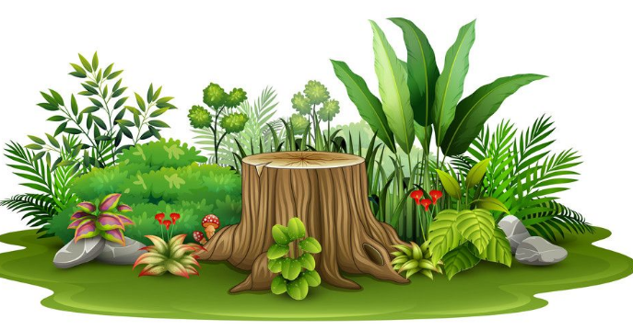

**Welcome back!**

**We hope you have had lovely Easter break!**

**Our main topics this term the ‘Seaside’**



Year 1 **phonics** screening takes place in the summer term (W/B 10th of June).

There are some excellent games and activities on [www.phonicsplay.co.uk](http://www.phonicsplay.co.uk). As always reading with the children and practicing the graphemes will help aid the children in their learning.

Please done hesitate to get in contact for any support.

**English -** We will be focusing on a range of fiction, non-fiction and poetry. We will be continuing to practise writing independently focusing on including a range of different punctuation and literary techniques. There will be lots of opportunities for reading in order to practise decoding and recognition of a wider range of words by sight.



**PE**

In PE we will be focusing on a range of movement and athletic games. We will be developing our running, throwing and jumping skills through a range of different challenges.

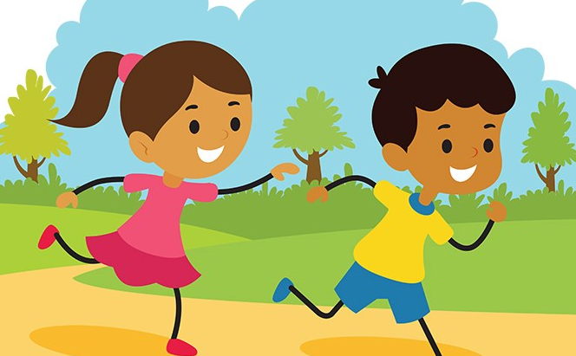

**Humanities (History, Geography & RE)**

Our Humanities topic is ‘**Seaside’.** This will focus on the human and natural features of the seaside and how they have changed over time including holidays, jobs and activities.

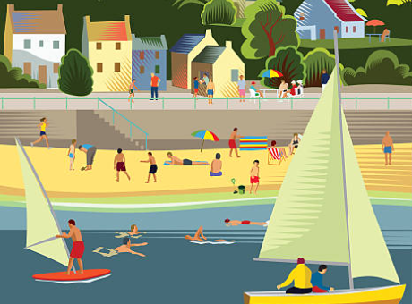

In RE the children will look at the theme of ‘**sacred texts’**. They will investigate and explore a range of significant sacred texts.

**Maths -** The main maths topics will be:

* **Multiplication and division:**  This will involve the children working with the 2’s, 5’s and 10’s timetables. We will also be looking at doubling and making groups as well as creating arrays.
* **Fractions:** This will involve creating halves and quarters of amounts of objects and numbers.
* **Geometry:** This will involve positons and direction. The children will be describing the position of shapes and describing their movements.

<https://whiterosemaths.com/parent-workbooks/>

**REMINDERS:**

Please provide you child with **a named water bottle** for use in the classroom. It should not contain juice or squash as a Healthy School we want to promote water as the best drink throughout the day. Please ensure that packed lunches do not contain any items with nuts. If you send a snack for your child, please choose a healthy one (not chocolate) – fruit or vegetable snacks are provided in school each day.

* **PE will be on a Wednesday and Thursday**. Your child will need navy shorts and a t-shirt in their house colour, but as most lessons will be taking place outside, please also ensure they have suitable warmer clothing i.e. plain navy jogging trousers and sweatshirt. They will also need suitable trainers for outdoor PE.
* If children have shoes with laces **they need to be able to tie them independently**.
* Please provide hairbands to tie back long hair.
* Should your child have **pierced ears, tape must be provided to cover the earrings during PE times in accordance with Health and Safety rules.** Please do endeavour to help teach your child to remove earrings on PE days.
* A spare pair of socks in their PE bags is also very useful. Please ensure all items of clothing and equipment are clearly named.
* Ensure that your child has correct school uniform including dark plimsolls and plain socks. Refer to the School Website to remind you about rules regarding school uniform. Nail varnish and tattoos should not be worn at school and reminders will be given to remove them if the need arises.
* Please don’t hesitate to email / contact if you have any queries or concerns: [Naomi.turner@panshanger.herts.sch.uk](mailto:Naomi.turner@panshanger.herts.sch.uk)
* We will also continue to use Tapestry as a means of contact.

**Music:** Music lessons will continue with Mr Mitchell. The children will explore the difference between rhythm and pulse through improvised movement exercises, singing games and instrumental playing.

**Art:** We will be looking at natural forms. We will be using found materials, clay and will explore the use of different artistic tools to help create a piece.



**Homework activities:**

**Reading**- As per the school policy children need to have their reading recorded 3 times a week in their reading record, practice will support your child to become a fluent reader. Regular reading will help them to decode new words using their phonic knowledge and to learn key words by sight. We will send home a mat with all common exception words if you would like them to practice.

**Spelling:** We will be sending home spellings each week. The spellings will be a combination of words with the same spelling pattern as well as common exception and high frequency words.