**Science**

**• Learning how to keep our bodies healthy.**

* **Finding out about food and nutrition.**
* **Learning about scientists and their discoveries about keeping healthy.**
* **Comparing things by looking for similarities and differences.**

**DT**

* **Kitchen skills for preparing fruit and vergetables**
* **Creating healthy snacks**

**Welcome back, I hope you had a good rest and are ready for the rest of the Autumn term.**

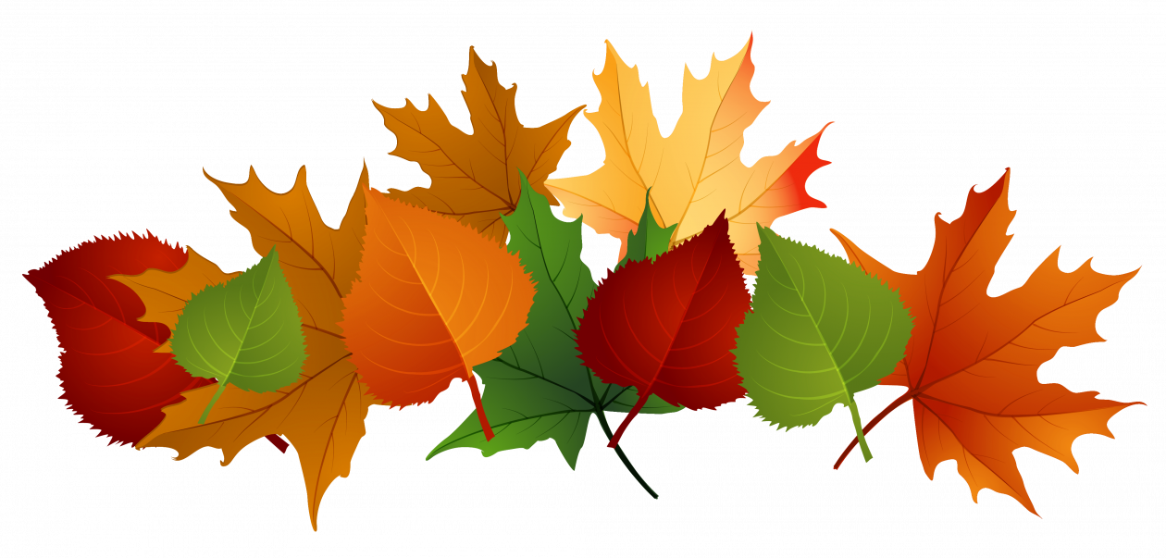

**Computing**

* **Practising basic word processing skills.**
* **Using software to publish writing.**
* **Saving and opening documents.**

**PSHE**

* **Celebrating differences and remaining friends**
* **Assumptions and sterotypes relating to gender**
* **Using the Zones to regulate our feelings**

- Saying sorry

We will be talking about:

- Joining a new c We will be talking about:

- Joining a new class.

- Making new friends/

Introducing ourselves

- Panshanger Golden Rules

- Why we have rules

- What would happen if there

were no rules

- Building confidence and self-

esteem

- Sharing celebrations

- Taking care of each other

- Identifying ways in which

stories can

represent a moral

- Making choices

- Stranger danger

- Saying sorrylass.

- Making new friends/

Introducing ourselves

- Panshanger Golden Rules

- Why we have rules

- What would happen if there

were no rules

- Building confidence and self-

esteem

- Sharing celebrations

- Taking care of each other

- Identifying ways in which

stories can

represent a moral

- Making choices

- Stranger danger

- Saying sorry

**English**

* **Sharing exciting stories by different authors to inspire our own writing.**
* **Developing fluency in reading through echo reading and using a story telling voice.**
* **Revising phonics from Y1 and applying to spelling.**
* **Learning new spelling patterns – adding ing, s, es.**
* **Practising correct letter formation and sizing of letters.**

**Music**

* **Playing high and low sounds**
* **Identifying tuned and untuned instruments**

**Art**

* **Creating own artwork using the skills practised last half term**

**PE**

**• This term we will begin a unit on dance. Skills will include moving in different ways and at different levels. The children will work in groups to create a sequence of movements.**

**•Gymnastics skills including balances and making a sequence of movements.**

**History**

**• Learning about the lives of famous people and considering why they are remembered.**

* **Using pictures and photographs to gather information about the past**
* **Giving reasons for the choices people made.**

**RE**

* **Learning about artefacts used in Muslim worship.**
* **Listening to the story of Hanukkah and writing our own version.**
* **Re-telling the Christmas story.**

**Maths**

* **Number and place value will continue to be the focus. Children will use the terms ones, tens, digits and multiples to talk about numbers and the patterns they notice.**
* **Continue to build confidence in using mental strategies to add and subtract including using known facts such as number bonds and regrouping numbers.**

**•Identifying 2D and 3D shapes. Recognising the properties of shapes and sorting them.**



**Tapestry**

I hope you have found my Friday updates useful to see what we have been doing in class during the week. If you have not been checking Tapestry, please do so as I add an update every Friday.

Messages for the week to come and details of home learning are also shared. Any learning that the children do at home can be uploaded as well.

**If anyone has a problem accessing their Tapestry account please get in touch.**

PE lessons will be on Thursday and Friday although the children need to have their PE kit in school all week as the lessons may change.

Lesson will take place inside or outside so it is essential that children should have navy jogging bottoms and a navy sweatshirt to wear for outdoor PE. Earrings should either be removed or covered with micropore tape.

PLEASE ENSURE EVERYTHING IS NAMED.

- Joining a new c We will be talking about:

- Joining a new class.

- Making new friends/

Introducing ourselves

- Panshanger Golden Rules

- Why we have rules

- What would happen if there

were no rules

- Building confidence and self-

esteem

- Sharing celebrations

- Taking care of each other

- Identifying ways in which

stories can

represent a moral

- Making choices

- Stranger danger

- Saying sorrylass.

- Making new friends/

Introducing ourselves

- Panshanger Golden Rules

- Why we have rules

- What would happen if there

were no rules

- Building confidence and self-

esteem

- Sharing celebrations

- Taking care of each other

- Identifying ways in which

stories can

represent a moral

- Making choices

- Stranger danger

- Saying sorry

**Home Learning**

We will continue to give out spellings and the maths challenge on Fridays. Reading should be done as regularly as possible to develop the chidlren’s fluency.

Children need to hand in:

**Wednesday:** Green maths challenge book

**Thursday:** Red spelling book

**Friday:** Reading records

Please don’t hesitate to contact me if you have any queries or concerns either by ringing the school office or by email:

[emma.waring@panshanger.herts.sch.uk](mailto:emma.waring@panshanger.herts.sch.uk)