**Happy New Year!**

**Welcome back, I hope you are well rested and ready for the new term.**

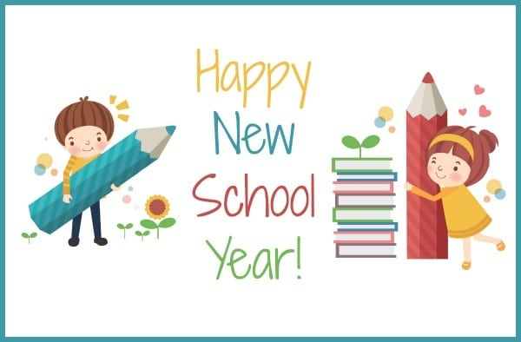

**Science**

**• Our next topic is all about Materials.**

**• Identifying and naming materials.**

* **Describing the properties of materials using scientific vocabulary.**
* **Learning about scientists and their discoveries about materials.**
* **Testing the properties of materials.**
* **Explaining why objects are made from certain materials.**

**Computing**

* **Listen to and describe music.**
* **Create music using Chrome Music Lab.**
* **Use tools to alter notes, rhythm, instruments and tempo.**

**PSHE**

* **This half term the theme is dreams and goals.**
* **We will think about our learning strengths and how we co-operate with others.**

- Saying sorry

We will be talking about:

- Joining a new c We will be talking about:

- Joining a new class.

- Making new friends/

Introducing ourselves

- Panshanger Golden Rules

- Why we have rules

- What would happen if there

were no rules

- Building confidence and self-

esteem

- Sharing celebrations

- Taking care of each other

- Identifying ways in which

stories can

represent a moral

- Making choices

- Stranger danger

- Saying sorrylass.

- Making new friends/

Introducing ourselves

- Panshanger Golden Rules

- Why we have rules

- What would happen if there

were no rules

- Building confidence and self-

esteem

- Sharing celebrations

- Taking care of each other

- Identifying ways in which

stories can

represent a moral

- Making choices

- Stranger danger

- Saying sorry



**History**

**• Learning about famous events and the impact they had on people and places at the time – The Fire of London.**

* **Using written sources to gather information about the past.**
* **Write historical recounts.**

**RE**

* **Learning about religious leaders.**
* **Why God is important to some people**
* **Asking big questions**

**Music**

* **Playing high and low sounds**
* **Identifying tuned and untuned instruments**

**Art**

* **Drawing buildings and looking at architecture**
* **Creating imaginary cities**
* **Using colour mixing skills.**

**PE**

**• In Dance we will be telling stories through movement.**

**• Improving our fitness through fitness activities and running.**

**•Gymnastics will focus on creating mini routines with jumps and turns.**

**English**

* **Using story maps to tell and create stories.**
* **Writing stories, recounts and instructions.**
* **Securing use of punctuation in sentences and using conjunctions.**
* **Devloping fluency in reading through echo reading and using a story telling voice.**
* **Applying phonics to spelling and learning new spelling patterns.**
* **Continuing to practise correct letter formation, size and position on the line.**

**Maths**

* **Number and place value will continue to be a focus of our daily fluency sessions.**
* **Continue to build confidence in using mental strategies to add and subtract including using known facts such as number bonds and regrouping numbers.**
* **Develop understanding of multiplication and divison as grouping and sharing.**

**• Counting pence and pounds and making amounts with coins.**



**Lost property**

We have had a lot of jumpers and cardigans go missing or have been left with some unclaimed. Please check that all uniform is named so we can make sure it gets back to the right person. This is really important if you have second hand uniform that may have a previous owners name in it.

It is really useful to have spare underwear and socks in your child’s PE bag. Unfortunately, our supply of extras has been depleted. If you have any donations of spare underwear or socks that would be appreciated.

**PE Kit**

PE lessons will be on **Monday** and **Thursday** although the children need to have their PE kit in school all week as the timetable may need to change.

For gymnastics children should have shorts to wear for using the apparatus. They should also have a navy jumper and jogging bottoms for outdoor PE.

If your child wears earrings they should either be removed (at home) or covered with micropore tape. Please provide micropore tape for your child to do this. It should be named and kept in their PE bag.

- Joining a new c We will be talking about:

- Joining a new class.

- Making new friends/

Introducing ourselves

- Panshanger Golden Rules

- Why we have rules

- What would happen if there

were no rules

- Building confidence and self-

esteem

- Sharing celebrations

- Taking care of each other

- Identifying ways in which

stories can

represent a moral

- Making choices

- Stranger danger

- Saying sorrylass.

- Making new friends/

Introducing ourselves

- Panshanger Golden Rules

- Why we have rules

- What would happen if there

were no rules

- Building confidence and self-

esteem

- Sharing celebrations

- Taking care of each other

- Identifying ways in which

stories can

represent a moral

- Making choices

- Stranger danger

- Saying sorry

Please don’t hesitate to contact me if you have any queries or concerns either by ringing the school office or by email:

[emma.waring@panshanger.herts.sch.uk](mailto:emma.waring@panshanger.herts.sch.uk)

**Reading**

Children should bring their book bag to school **everyday**, with their reading book and reading record. There are lots of opportunities during the week to read to an adult. Books may be changed when we hear the children read or they can ask Mrs Graves to change their book when they have finished.

Please write in the reading record at least 3 times a week to show what reading has been done at home. This does not have to be solely the school reading books.

**Spelling**

We will continue to send home new spellings to learn on Fridays with the test on Thursdays.

**Maths Challenge**

The children have been doing very well with the Year 2 Maths Challenge. Lots of you have now moved on to multiplication and division facts for the 2, 10 and 5 times tables. Remember to keep practising the other facts, even after you have got your certificate so you don’t forget them!

Here are some websites to help practise the facts.

<https://www.ictgames.com/>

<https://www.topmarks.co.uk/maths-games/hit-the-button>