**Year Three Summer 1 Newsletter**

**We hope you have all had a lovely, relaxing break and are looking forward to the summer term. We have got lots planned as usual! Let’s hope for some good weather too!**

**Science**

Our new topic is all about plants, looking at parts of a plant, germimination, pollination, bees and plant lifecycles We will investigate what plants need to grow well and grow some plants ourselves, including potatoes which hopefully we will be able to harvest and eat later in the term!

**Computing**

Our new topic is programming. We have been sent some BBC microbits (mini computers) so we will start our work by investigating these together!

**PSHE**

Our new topic is ‘Relationships’ which includes family roles and responsibilities, friendship and online safety.

Saying sorry

We will be talking about:

- Joining a new c We will be talking about:

- Joining a new class.

- Making new friends/

Introducing ourselves

- Panshanger Golden Rules

- Why we have rules

- What would happen if there

were no rules

- Building confidence and self-

esteem

- Sharing celebrations

- Taking care of each other

- Identifying ways in which

stories can

represent a moral

- Making choices

- Stranger danger

- Saying sorrylass.

- Making new friends/

Introducing ourselves

- Panshanger Golden Rules

- Why we have rules

- What would happen if there

were no rules

- Building confidence and self-

esteem

- Sharing celebrations

- Taking care of each other

- Identifying ways in which

stories can

represent a moral

- Making choices

- Stranger danger

- Saying sorry

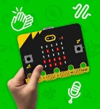



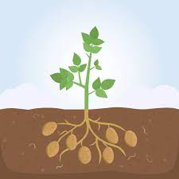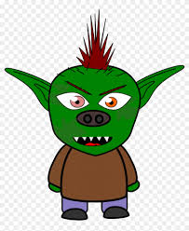

**Music**

The children will continue to work with Mr Mitchell on a weekly basis. Lessons will include developing musical independence by playing rhymic pieces in 2 parts and composing rhythm phrases.

**Art**

* Designing and creating mosaics in the style of the French street artist ‘Invader.’.De
* Peruvian masks and textile llamas linked to our geography topic.

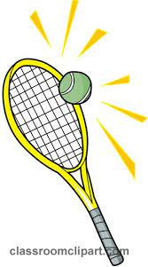

English

Traditional Tales based on the the book ‘The Finger Eater’ by Dick King-Smith.

Creating a tourist guide for Peru linked to our geography.

Instructional writing, which will include following instructions for a range of activities and then writing our own for different purposes.

**PE**

PE lessons this half term will include cricket skills and mini games and we will continue with our tennis unit.

We will also take part in some more orienteering activities linked to a range of subjects.



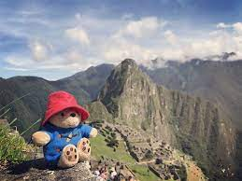

**Maths**

We will finish oouir mass and capacity topic and then move onto fractions. money and time. As telling the time can be a tricky concept, this would be a great thing to start practising at home now!

We will also continue with our fluency sessions to develop and consolidate essential maths skills, such as times tables, doubles and halves and number bonds. Top Marks is a good website for practising bonds and doubles as well as other topics. TT Rockstars allows children to practise times tables and play against others if they want to. The ‘Maths Challenge’ will continue every Tuesday. Great work last term – please keep this up!

**Geography**

Our new topic is Peru and we will compare its three different regions - the rainforest, coast and mountains. We will also find out about Machu Picchu and the Incas, and Peru as a holiday destination.

**RE**

We will look at rules in religions, the five pillars of Islam, Ramadan and Id and giving to charity.

Rules in religions

Five pillars of Islam Rules in religions

Five pillars of Islam

Ramadan & Id

Giving to charity

Ramadan & Id

Giving to charity

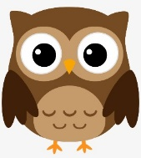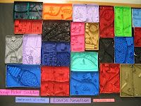 

**Spanish**

‘Saying what I and others do’. We will learn how to identify and use verbs in their infinitive and conjugated forms for singular persons (I, you, he,she,it). We will begin to use singular definite articles with nouns that have clear gender endings and those that are not clear (not ending in –o or –a). Whilst having some awareness already of –ar ending verbs, the children will now encounter –er ending verbs through listening, speaking, reading and writing.

begin to use singular definite articles with nouns that have clear gender endings and those that are not clear (not ending in –o or –a). Whilst having some awareness already of –ar ending verbs, the children will now encounter –er ending verbs through listening, speaking, reading and writing.

with nouns that have clear gender endings and those that are not clear (not ending in –o or –a). Whilst having some awareness already of –ar ending verbs, the children will now encounter –er ending verbs through listening, speaking, reading and writing.

**Useful Websites**

**What is a plant -** [**https://www.bbc.co.uk/bitesize/topics/zy66fg8/articles/zcjnp39**](https://www.bbc.co.uk/bitesize/topics/zy66fg8/articles/zcjnp39)

**Pollination –** [**https://www.bbc.co.uk/teach/class-clips-video/science-ks1-ks2-ivys-plant-workshop-what-is-pollination-and-how-does-it-work/zv4df4j**](https://www.bbc.co.uk/teach/class-clips-video/science-ks1-ks2-ivys-plant-workshop-what-is-pollination-and-how-does-it-work/zv4df4j)

**Maths Activities** This site includes ‘Hit the Button’ -great for number bonds, doubling and halving and times tables. [**https://www.topmarks.co.uk/Search.aspx?Subject=16&AgeGroup=3**](https://www.topmarks.co.uk/Search.aspx?Subject=16&AgeGroup=3)

**Peru**

[**https://www.natgeokids.com/uk/discover/geography/countries/country-fact-file-peru/**](https://www.natgeokids.com/uk/discover/geography/countries/country-fact-file-peru/)

[**https://www.dkfindout.com/uk/history/incas/machu-picchu/**](https://www.dkfindout.com/uk/history/incas/machu-picchu/)

**Reminders**

Please bring a named bottle filled with fresh water every day. This is particularly important when the weather gets warmer. Healthy snacks can be brought for playtime. PE kits can be left at school for the half-term. If PE trainers don’t fit in the bag, then a separate drawstring bag can be brought. Please make sure all bags, shoes, and items of clothing are named.

**Home Learning Tasks**

Weekly spellings based on our work in school will be sent home on Fridays and tested in school on the following Thursday. There will be a spelling shed activity each week which links to the main class spelling work.

You should read at home as much as possible and these sessions should be recorded and signed by an adult in your reading record. Books can be changed on any day of the week (as long as you can read it fluently and talk about the story). Library books can be borrowed as well.

Practising for the weekly maths challenge. Try to aim for a certificate every 2 weeks! TT Rock Stars or Hit the Button. Aim for a few 10-15 minute sessions a week to help you develop your maths skills.

You are also very welcome to carry out your own research by using books or the world wide web (with your adult’s permission).

!

Please don’t hesitate to get in touch if you have any queries or concerns. You can make an appointment for after school, or have a brief chat with any of the year 3 staff at the classroom door. We are always happy to help!

You can also contact me on the address below.

[rebecca.puddephatt@panshanger.herts.sch.uk](mailto:rebecca.puddephatt@panshanger.herts.sch.uk)

**PE**

Year 3 will usually have PE on Mondays and Thursdays, although the children need to have both their indoor and outdoor PE kit in school all week as the lessons may change. Please check that they do have everything by referring to the list on the webite. Earrings should be covered with the child’s own tape or removed, although it is easier not to wear earrings on P.E days. Please make sure you have a water bottle as we usually take these outside with us during lessons.

- Joining a new c We will be talking about:

- Joining a new class.

- Making new friends/

Introducing ourselves

- Panshanger Golden Rules

- Why we have rules

- What would happen if there

were no rules

- Building confidence and self-

esteem

- Sharing celebrations

- Taking care of each other

- Identifying ways in which

stories can

represent a moral

- Making choices

- Stranger danger

- Saying sorrylass.

- Making new friends/

Introducing ourselves

- Panshanger Golden Rules

- Why we have rules

- What would happen if there

were no rules

- Building confidence and self-

esteem

- Sharing celebrations

- Taking care of each other

- Identifying ways in which

stories can

represent a moral

- Making choices

- Stranger danger

- Saying sorry

