

**Science**

**We are just completing our unit on Living Things and Their Environment. We have had a great time investigating the school site looking for signs of animal life and investigating the preferences of woodlice! We will end the unit by looking at animal defence and hibernation then exploring how different animals look after their young. We will then move onto our second topic all about Sound. In this unit we will explore how sound is made, how it travels and how our ear works to hear it!**

**Art**

**In this half term some of our artwork will have a ‘winter’ theme and will include creating 3d structures using a range of media such as clay, paper, card and wool! We will also continue to explore the piece ‘Four Trees’ by Eigon Schiele and will explore the skeletal leaf sculpture work by Kay Sekimachi.**

**Computing**

**We have a few lessons left of our Authoring unit where the children will learn to use action buttons and hyperlinks. They will then put their Power Point skills to the test by designing a document which demonstrates all of the new things that they have practiced such as page transitions, contents tables and buttons to navigate from page to page.**

**After this, we will begin a unit on touch typing using the BBC Dance Mat program. This will slowly introduce the children to the different keys and the correct fingers to type them with.**

- Saying sorry

We will be talking about:

- Joining a new c We will be talking about:

- Joining a new class.

- Making new friends/

Introducing ourselves

- Panshanger Golden Rules

- Why we have rules

- What would happen if there

were no rules

- Building confidence and self-

esteem

- Sharing celebrations

- Taking care of each other

- Identifying ways in which

stories can

represent a moral

- Making choices

- Stranger danger

- Saying sorrylass.

- Making new friends/

Introducing ourselves

- Panshanger Golden Rules

- Why we have rules

- What would happen if there

were no rules

- Building confidence and self-

esteem

- Sharing celebrations

- Taking care of each other

- Identifying ways in which

stories can

represent a moral

- Making choices

- Stranger danger

- Saying sorry

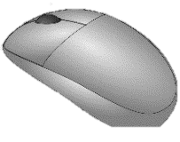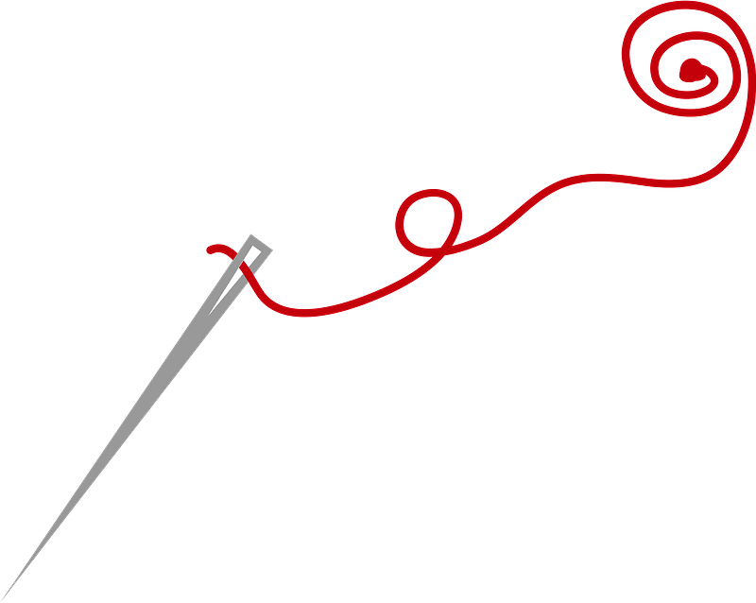

**English**

**We will kick off this half term by completing our non-fiction unit on Information Texts. The children will link their English and Science knowledge to write a non-chronological report about an animal of their choice. We will then move onto a lovely unit based around the book ‘The King Who Banned the Dark’ by Emily Haworth-Booth, where we will explore the features of persuasive writing. Our final units of 2023 will be ‘Instructions and Explanations’ and a lovely unit on Performance Poetry which focusses on speaking aloud to an audience.**

**Design Technology**

**The children will begin an exciting new textiles unit in which they will recycle an old T-shirt into a reusable bag! They will practice different types of stitches on binca and then on material, deciding which one is best to sew a strong seam. They will then design and decorate their completed sewn bag which they can then bring home to use. This unit also explores the importance of recycling and using less plastic.**

**It has been a pleasure getting to know your children and I am very much looking forward to another fun-packed half-term with them!**



**Humanities (History, Geography & Religion)**

**Our History topic on Ancient Egypt will continue through this half-term. We will be exploring the Egyptian Gods, the construction of the pyramids and considering what the greatest achievements of this civilisation were. We will also continue our Geography topic all about Deserts which will explore how the desert is used and lived in today. In Religion we will be find out about how food is used in worship in**

**Christianity and Sikhism. We will then learn about some**

**Christmas traditions in other parts of the world.**

**Maths**

**Daily lessons will include one main lesson and a short fluency session to improve speed, accuracy and reasoning.**

**We have completed two large units focussed on Place Value and Addition and Subtraction. Between now and the end of term we will complete a two-week unit on Length and Perimeter, followed by a longer unit on Multiplication and Division. The children will also continue to practice their times table and division skills in preparation for the National Times Table Check in June.**

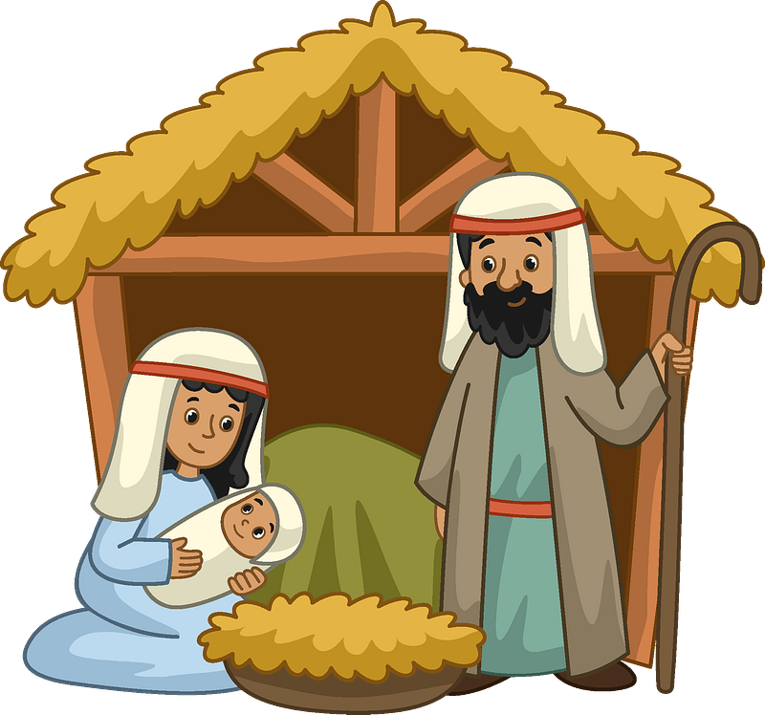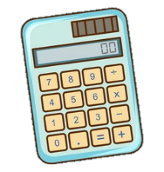

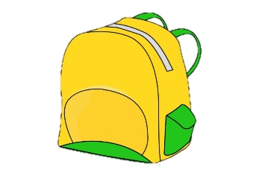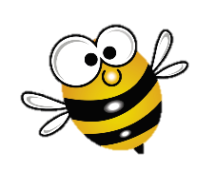

**Spanish**

**Spanish continues with opportunities to develop the language through reading, writing, speaking (singing!) and listening. There will be conversations, games, Q & A sessions and the children will continue to describe things and people and begin to express likes and dislikes. They will endeavour to improve their pronunciation and spelling. The children will learn about how Christmas is celebrated Spain and other Spanish speaking countries.**

**Reminders**

**A full indoor PE kit should remain in school on your child’s peg and should have their name inside so that we can reunite lost items with the correct owner quickly. All children need a warm, waterproof coat for playtimes and sensible shoes for using the climbing frame at playtimes and lunch times. Please remember to order your child’s school lunch. Meals for the whole of the half term are available to order now on**

**School Grid.**

**Year Four have been given their second ‘batch’ of spellings. I have been very impressed at the hard work they have put into achieving high scores in their weekly tests. The current laminated sheet provides all of the weekly words up to the end of the term and there are dates at the top of each set to help you identify which words to learn and when.**

**Whilst you continue to practice key vocabulary at home, in school our spelling work will focus on learning the rules for forming plurals such as adding s/es/ies and changing f to ves.**

**All children are still expected to read regularly at home and reading records will continue to be checked on Fridays. In class there will be a guided reading session each week as well as a comprehension activity and sharing of our class novel which is currently ‘Charlotte’s Web’ by EB White. Please ensure that your child reads regularly and widely at home as it is so important for the development of all areas of the curriculum.**

**This half term there will be two PE sessions. The first will be on Monday afternoon and will be an indoor dance session. The children will create dance phrases based on the theme of ‘Cold Places’ reflecting the movements of snowflakes, penguins and polar bears!**

**On Friday mornings we will continue with our unit on Gymnastics. This is also an indoor session. The children will be using the large apparatus, climbing frame and ropes to form sequences that include balances, travelling and different types of roll. Please make sure that your child has their coloured house team t-shirt and shorts for these sessions.**

- Joining a new c We will be talking about:

- Joining a new class.

- Making new friends/

Introducing ourselves

- Panshanger Golden Rules

- Why we have rules

- What would happen if there

were no rules

- Building confidence and self-

esteem

- Sharing celebrations

- Taking care of each other

- Identifying ways in which

stories can

represent a moral

- Making choices

- Stranger danger

- Saying sorrylass.

- Making new friends/

Introducing ourselves

- Panshanger Golden Rules

- Why we have rules

- What would happen if there

were no rules

- Building confidence and self-

esteem

- Sharing celebrations

- Taking care of each other

- Identifying ways in which

stories can

represent a moral

- Making choices

- Stranger danger

- Saying sorry

**Should you have any queries or concerns, please do not hesitate to contact me at:** [**gail.burt@panshanger.herts.sch.uk**](mailto:gail.burt@panshanger.herts.sch.uk) **I will endeavour to respond as quickly as I can. If you prefer to chat face to face, I am available on most Wednesdays after school. Please drop in if you have any worries!**