**Science**

**Our science unit this half term will be all about electricity. The children will explore the symbols for electrical components, how to make a successful circuit, how a circuit can be broken or interrupted using conductors and insulators and electrical safety in the home.**

**Computing**

**This half term we will begin a unit on Photo Editing where the children will learn to:**

* **make changes to an image and then save the image as a new version.**
* **change the composition of images.**
* **change images for different uses.**
* **retouch images and**
* **recognise fake images.**

We will be talking about:

- Joining a new c We will be talking about:

- Joining a new class.

- Making new friends/

Introducing ourselves

- Panshanger Golden Rules

- Why we have rules

- What would happen if there

were no rules

- Building confidence and self-

esteem

- Sharing celebrations

- Taking care of each other

- Identifying ways in which

stories can

represent a moral

- Making choices

- Stranger danger

- Saying sorrylass.

- Making new friends/

Introducing ourselves

- Panshanger Golden Rules

- Why we have rules

- What would happen if there

were no rules

- Building confidence and self-

esteem

- Sharing celebrations

- Taking care of each other

- Identifying ways in which

stories can

represent a moral

- Making choices

- Stranger danger

- Saying sorry

**Art**

**We will be looking at the work of famous artists such as Pablo Picasso, Andy Goldsworthy and Guiseppe Archimboldo. We will explore their unique techniques and practice creating work in their styles.**

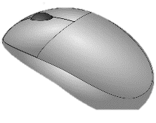

**English**

**We will be focussing on discussion texts for the first part of this half term. The children will learn how to present a balanced argument on topics such as ‘should children have to wear school uniform?’ and ‘should animals be kept in zoos?’ After that, we will be exploring the graphic novel version of Oliver Twist! This is a really fun way to study a classic story and we will look in depth at the characters and plot in the story as well as the Victorian author Charles Dickens.**

**Design Technology**

**Our final DT topic for the year will link to our science work on electricity. The children will use what they learn about electricity to create a simple torch and burglar alarm that can be controlled with different types of switches.**

**Welcome back everyone! I hope you all had a wonderful Easter break and did not eat too much chocolate!**





**Maths**

**The main focus for Fluency sessions this half term will be speed and agility in times tables up to 12x12 in preparation for our National Times Table check in early June. In daily lessons for the first three weeks we will be exploring decimals. In year four we look at decimal numbers up to 2dp. After this we will do some lighter units on time and shape. As these are shorter units, there may be homework assigned to help support and extend the children’s learning opportunities.**

**Humanities (History & Religion)**

**In Religion we will be looking at important customs in Christianity, Sikhism and Hinduism and how they vary in a lovely topic about ‘belonging’. Our history topic this term is called ‘Victorian Children’ and will encourage the children to compare and contrast the lives of both wealthy and poor Victorian children with their own lives. We will look at characters and movements that were instrumental in shaping the lives we have today such as Dr Barnardo and the Education Act.**

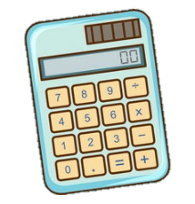

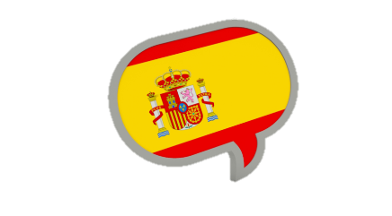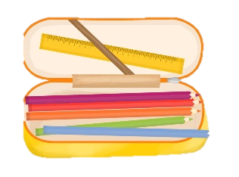

**Spanish**

**The children will recap some of their previous learning this term in the unit ‘Describing Me and Others’. There will be an emphasis on asking and answering questions and reinforcing forms of the very tricky irregular verb for *to be* (*estar*). There will be more use of plural nouns and therefore adjectives in their plural form as well as plural articles.**

**PE**

**To begin with, the children will complete their current Dodgeball unit with Miss Gottlieb on Monday afternoons. This is an indoor session. Later, there will be an outdoor athletics session with Miss Gottlieb and a further indoor session with some Year 12 students from Ridgeway Academy. Further details will follow.**

- Making new friends/

Introducing ourselves

- Panshanger Golden Rules

- Why we have rules

- What would happen if there

were no rules

- Building confidence and self-

esteem

- Sharing celebrations

- Taking care of each other

- Identifying ways in which

stories can

represent a moral

- Making choices

- Stranger danger

- Saying sorrylass.

- Making new friends/

Introducing ourselves

- Panshanger Golden Rules

- Why we have rules

- What would happen if there

were no rules

- Building confidence and self-

esteem

- Sharing celebrations

- Taking care of each other

- Identifying ways in which

stories can

represent a moral

- Making choices

- Stranger danger

- Saying sorry

**Personal, Social and Health Development  
PSHE for Summer 1 will focus on relationships, exploring issues such as jealousy, getting on and falling out, love and loss and strategies for coping with feelings and situations. The unit will encourage children to talk about people that are special to them and memories that they cherish.**

**Reading  
Reading is a crucial skill in Year four. What children read can greatly influence how they progress as writers, how they structure their speech and their variety of vocabulary. It is therefore important that your child is regularly accessing a wide range of age appropriate (and challenging) texts, in a range of genres that will help them to develop their literacy skills.**

**Should you have any queries or concerns, no matter how big or small, please do not hesitate to contact me at school via Admin or through my own email:** [**gail.burt@panshanger.herts.sch.uk**](mailto:gail.burt@panshanger.herts.sch.uk) **I will endeavour to respond as quickly as I can! Alternatively, I am available after school on Wednesdays and Thursdays should you prefer to speak face to face.**

**General**

**Spellings for the week will continue to start each Monday to be tested on Friday morning. Your child has received their new set of spellings which start on Monday 15th April. Your ongoing support with spelling work is much appreciated :) Reading records will be collected each Monday morning so that I can monitor what children are reading and how they are getting on. I have really enjoyed looking at the range of texts that the children are reading. If there is an author that your child is particularly interested in, please ask as I am almost certain I will have something in my own bookshelves! As we come into the warmer part of the school year, please ensure that your child has a water bottle in school as our classroom gets very hot!**

**We will be reading The Sheep Pig by Dick King Smith as our class novel this half term!**

**Geography  
This term our topic will be ‘Settlements’. In this unit we will explore why people settle in different places and why only some settlements grow. We will look at the key features of the main settlement types such as Farms, Hamlets and Villages. We will also look at the counties and major cities of the UK.**