**Year 6 newsletter – Autumn 2**

Well done for a very good first half term in Year 6. The children have quickly learnt the routines and are coping very well with having different staff teaching different subjects – great practise for secondary school.

Another busy half term coming up – remember to ask if you are not sure of anything!

**Spanish - Lessons will continue to encompass the key skills of listening, speaking, reading and writing in Spanish. The focus is on ‘Saying what I and others do’ using –er and –ar ending verbs and conjugating them for plural persons (we, they). This will also encompass asking and answering questions, using negatives as well as positives and using possessive adjectives e.g. my book /s, your dog/s.**

- Joining a new c We will be talking about:

- Joining a new class.

- Making new friends/

Introducing ourselves

- Panshanger Golden Rules

- Why we have rules

- What would happen if there

were no rules

- Building confidence and self-

esteem

- Sharing celebrations

- Taking care of each other

- Identifying ways in which

stories can

represent a moral

- Making choices

- Stranger danger

- Saying sorrylass.

- Making new friends/

Introducing ourselves

- Panshanger Golden Rules

- Why we have rules

- What would happen if there

were no rules

- Building confidence and self-

esteem

- Sharing celebrations

- Taking care of each other

- Identifying ways in which

stories can

represent a moral

- Making choices

- Stranger danger

- Saying sorry

**Science - Electricity will be our new topic. We will investigate: simple circuits with switches / which materials make the best conductors and how components work in series and parallel circuits. This will involve lots of practical work investigating how electricity travels through different circuits and what effects this. We will create circuits and practise drawing them using the correct representations for circuits using symbols.**





**English -** Our first text will be ‘Wisp’ - a story about a small boy with big hopes and dreams. We will be focusing on using variety of sentence structures, such as: single clause sentences and multi-clause sentences using coordinating conjunctions.

Spellings will continued to be tested each week and the children need to have their reading records signed at least 3 times a week which will be checked on a Friday.

We will continue to teach SPaG separately and then make use of the learning in all our writing sessions.

**PE - We will be starting units in gymnastics and dance. Sometimes our lessons change days so please make sure you have your PE kit in school all week.**





**Geography - The topic in Geography will be continuing our topic of Extreme Earth. We will be focusing on hurricanes, tornadoes, and flooding and considering the damage they cause as well as how safety measures for extreme events have developed.**

**RE - we will be studying the role of the Delai Lama, as a religious leader in Buddhism as well as exploring the idea of a sacred and secular Christmas.**

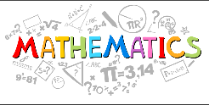

**Maths**

* **Daily lessons including one main session and one or two short fluency sessions.**
* **The children will be encouraged and taught to explain their decisions, methods and results in different ways using mathematical language and number sentences**
* **We will begin by identifying, adding and subtraction fractions and move onto multiplying and dividing them including finding fractions of amounts.**







**Yr. 6 SATs take place in the week beginning Monday 13th May 2024.**

**More information will be shared with parents and children as the year goes on.**

**School journey to the Norfolk has been booked for the week beginning Monday 15th May 2023. Please remember to send back the slip stating whether your child would like to attend or not. If for any reason a child does not go they are expected to be in school for the week, working in Year 5.**

**Computing - Our topic for the half term is variables in games. We will be looking at variables and using them to create our own project and apply this to improve games in Scratch.**

**PSHE - Celebrating differences. This will include celebrating differences, working and playing together and bullying.**

**We will also be continuing our work on Zones of Regulation. This will allow children to identify their own emotions and have strategies to move from one to another.**

represent a moral

- Making choices

- Stranger danger

- Saying sorrylass.

- Making new friends/

Introducing ourselves

- Panshanger Golden Rules

- Why we have rules

- What would happen if there

were no rules

- Building confidence and self-

esteem

- Sharing celebrations

- Taking care of each other

- Identifying ways in which

stories can

represent a moral

- Making choices

- Stranger danger

- Saying sorry



**Reading at home**

**The children are expected to read regularly at home and a comment should be added to the reading record which will be checked by Mrs Quinn on a Friday. PLEASE continue with the reading practise at home as it is so important in all apsects of the curriculum.**

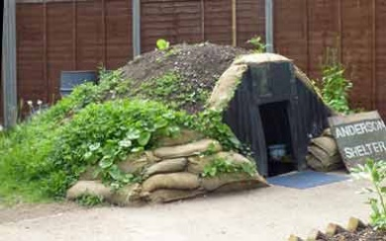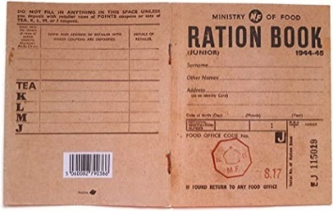

**Art -** Year 6 will be exploring the theme of ‘costume’. We will be looking at the work of artists to study the techniques used. We will be painting on a variety of surfaces and applying pattern and texture to emblesh paintings.

* Make studies of artist’s work to learn the techniques and processes used.

Please contact us if you have any queries or concerns:

[amanda.reed@panshanger.herts.sch.uk](mailto:amanda.reed@panshanger.herts.sch.uk)

[jill.gh@panshanger.herts.sch.uk](mailto:jill.gh@panshanger.herts.sch.uk)

nina.wright@panshanger.herts.sch.uk

**Year 6 will be set homework – they will have weekly spellings words and reading tasks.**

**There may be additional tasks that could be any subject e.g. a history task / a science investigation / research into a geography topic etc.**

**History / DT - We will continue our WW2 work focussing on rationing and the effect it had on families.**

**The children will design and make their own Anderson shelter using a range of DT skills.**